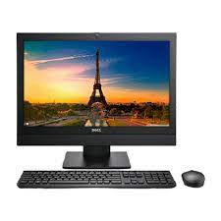

DELL OPTI 3240

* All-In-One-With Stand
* Memory Speed: 1600 MHz
* Supported Size: 16 GB
* Intel HD Graphics 530
* **Rs.40,000**